
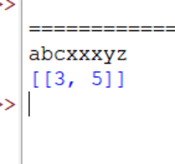

Session-3 Lab Program
Teeka Raman S(192511131)
1.
Code:
class Solution:
def largeGroupPositions(self, s: str) -> list[list[int]]:
result = []
i = 0
n = len(s)
while i < n:
j = i
while j < n and s[j] == s[i]:
j += 1
if j - i >= 3:
result.append([i, j - 1])
i = j
return result
s = input()
obj = Solution()
print(obj.largeGroupPositions(s))
Output:
2.
Code:
board = eval(input())
m = len(board)
n = len(board[0])
result = [[0] * n for _ in range(m)]

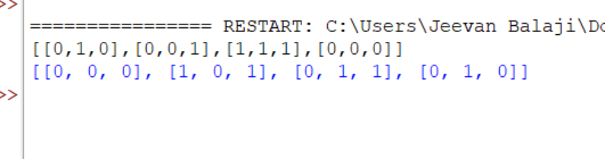

for i in range(m):
for j in range(n):
count = 0
for x in range(max(0, i - 1), min(m, i + 2)):
for y in range(max(0, j - 1), min(n, j + 2)):
if (x, y) != (i, j) and board[x][y] == 1:
count += 1
if board[i][j] == 1 and count in (2, 3):
result[i][j] = 1
elif board[i][j] == 0 and count == 3:
result[i][j] = 1
print(result)
Output:
3.
Code:
poured = int(input())
query_row = int(input())
query_glass = int(input())
glasses = [[0.0] * (i + 1) for i in range(query_row + 1)]
glasses[0][0] = poured

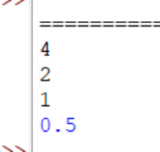

for i in range(query_row):
for j in range(i + 1):
excess = max(0, glasses[i][j] - 1) / 2
glasses[i + 1][j] += excess
glasses[i + 1][j + 1] += excess
print(min(1.0, glasses[query_row][query_glass]))
Output:

